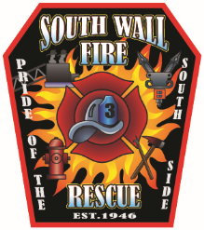
WALL FIRE DISTRICT NO. 3
PO Box 542 Allenwood, NJ 08720
www.southwallfire.com
Phone: 732-223-1134 Fax: 732-223-2415
Email: Chief@southwallfire.com
John A. Sahatjian
Chief Of Department

PRESS RELEASE

FOR IMMEDIATE RELEASE
April 5, 2018

Subject: Firehouse Tour

Contact: John A. Sahatjian Fire Chief

“Brownie Tour”

On Tuesday, May 1, 2018 the local Brownie Troop took part in a firehouse tour of South Wall Fire House on Atlantic Ave.

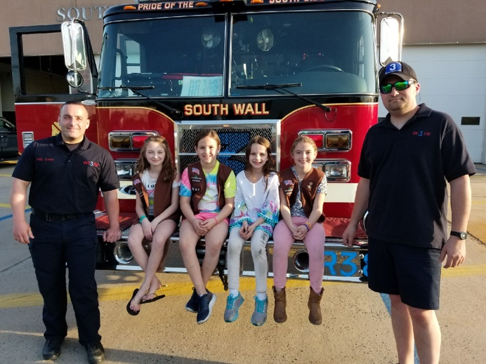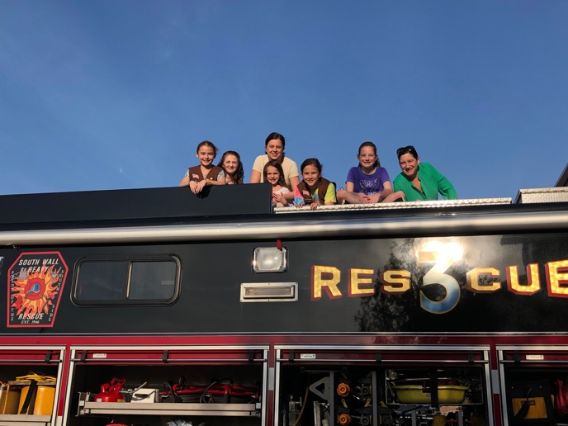

The girls were shown the fire trucks, firefighting gear and much more. They were also explained about fire safety in their homes and how important smoke detectors are.

Our dedicated volunteers are always willing to give firehouse tours, please contact us or visit our Facebook or website for more information.
www.southwallfire.com

